# User Requirement

*Ecommerce store wishes to analyze its past business data and prepare their future business plans, customer wishes to know which platform attracts their customer and what are the major factors that contributes to business sale.*

# Report Based on Analysis of past business data

## Evaluation of effect of different platform on sales

Below are graphical representation of effects of App and website on total sales

### Website

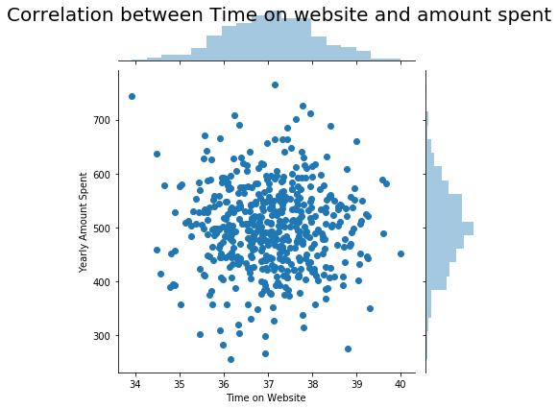

### App

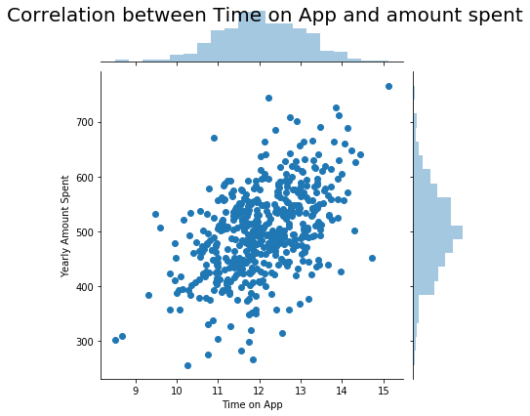

### Inference

When we compare the App to website, App graph shows little inclination from which we can infer to some extent App platform does have more positive impact on sales rather than website

### Other factors effect

Consolidated graph showing effect of all the features on sales

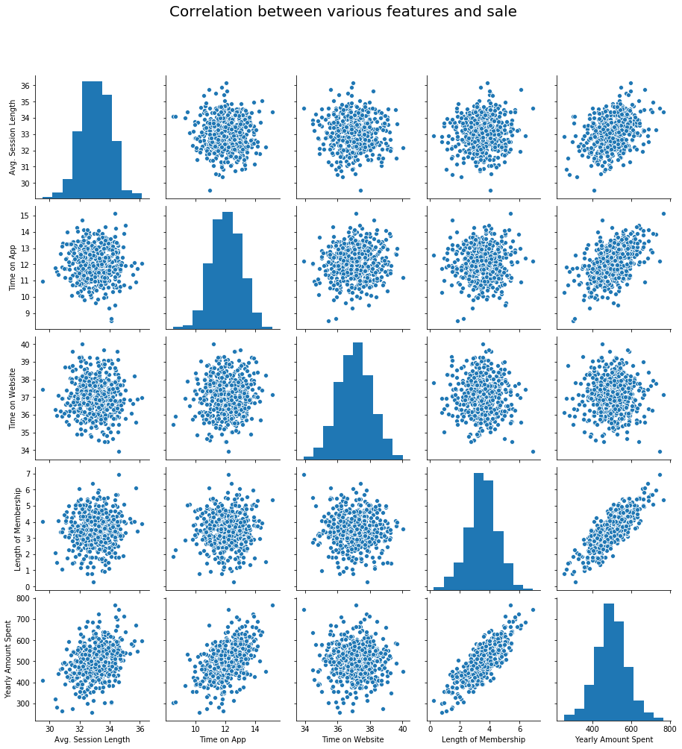

#### Heat Map

Heat Map depicting the effect of various features on sale

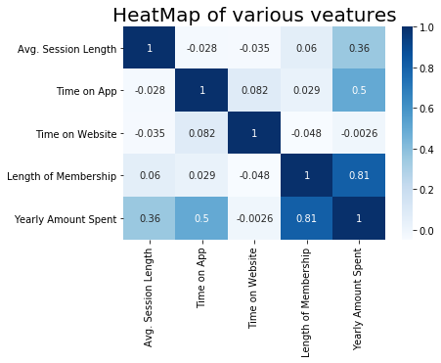

### Inference

From above graphs we can see that length of membership has greater impact on sales compared to other features, next to that Time on App has greater impact on sales

## Machine Learning Model

To confirm the above inference we created an ML model to predict the sales

### APP vs Sales

Below is the graph showing the concurrence between the predicted and the past original value with respect to App Time

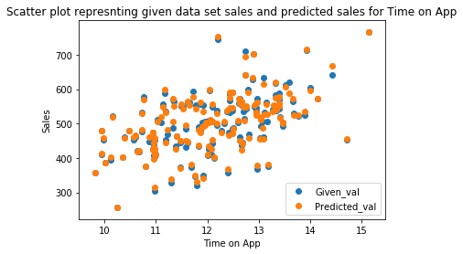

### Website vs Sales

Below is the graph showing the concurrence between the predicted and the past original value with respect to website Time

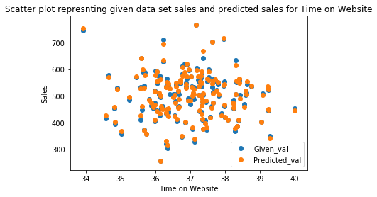

### Membership Time vs Sales

Below is the graph showing the concurrence between the predicted and the past original value with respect to length of membership

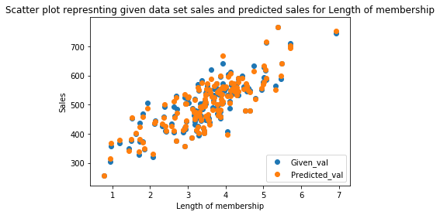

Below is the graph showing the concurrence between the predicted and the past original value

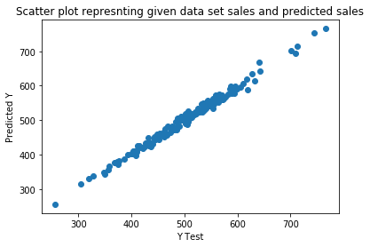

### Inference

We have root mean squared error for this model as 8.933, which means our prediction of sales differ on average of 8.933 unit with original sale, which is better and can be relied.

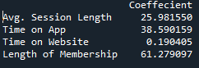

Above shown is the coefficient of various features on predicting the sales by the model. Higher the coefficient higher its impact on sales. From the data we can see length of membership has more impact than any other features. After that time spent on App has more impact on the sales.